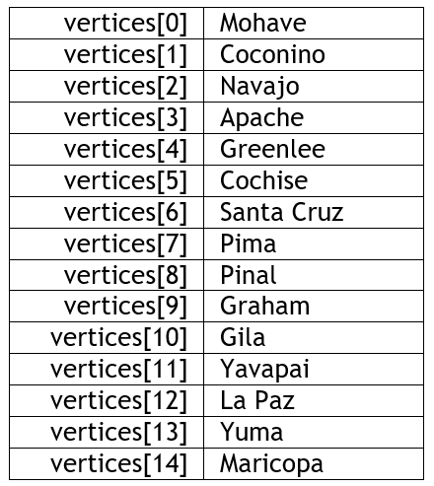The purpose of this assignment is to assess your ability to:

* Implement a graph abstract data type.

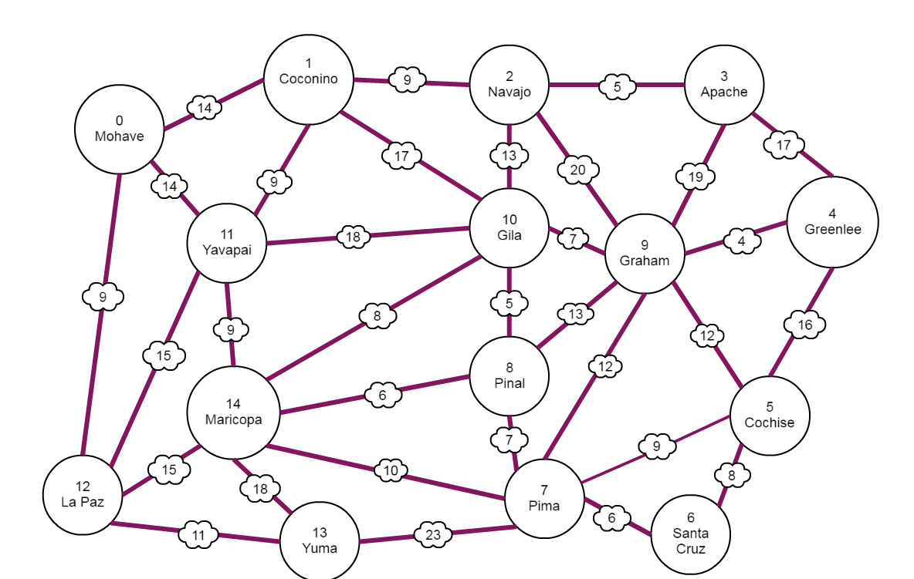A graph is a set of vertices and a set of edges. Represent the vertices in your graph with an array of strings:

Represent the edges in your graph as a two-dimensional array of integers. Use the distances shown in the graph pictured here.  
  
Add the following functions to your graph class:

* A getDistance function that takes two vertices and returns the length of the edge between them. If the vertices are not connected, the function should return the max value for an integer.
* A getNeighbors function that takes a single vertex and returns a list of all the vertices connected to that vertex.
* A print method that outputs an adjacency matrix for your graph.

Write a test program for your Graph class. Create a Loom video in which you walk through your code and execute your program. Be sure your test program demonstrates all functionality. When you are finished, submit the following:

1. Your code in a zip file
2. A statement that the submitted work is your own
3. A document containing a link to your Loom video